Inferential data Analysis
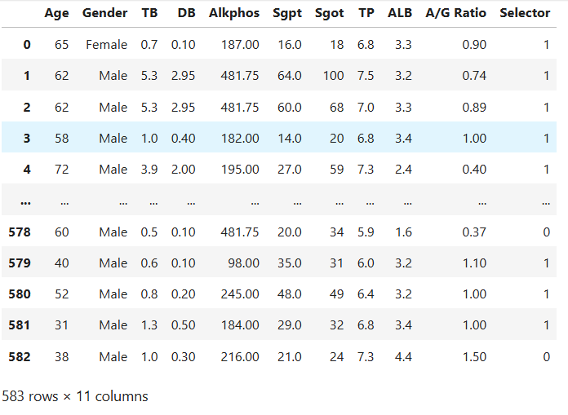
Covariance: Difference between the columns
- The feature ‘TB’ is positively covariance in ‘DB’ and ‘Selector’ features.
- The feature DB is positively covariance in sgot and selector (linear upward direction) and Negatively covariance (linear downward) in ALB features.
- The ALB is negatively covariance in TB, DB and Selector features.
Correlation: Correlative between the columns
- The feature ALB and Alkphos are correlated each other.
Ttest: Ttest is the test to similarity between given variables based on Mean.
- Unpaired ttest-Independent variable-different groups with same condition.
- Paired ttest-Dependent variable-same group and different condition.
- Through pvalue can find the similarity. If p<0.05, Reject null hypothesis else p>=0.05,Fail to reject .
- H0(null hypothesis)-There is no similarity between given variables
- H1-There is a similarity difference between given variables

Indep_ttest
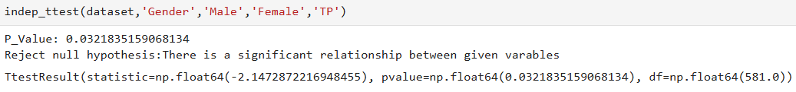
Dep_ttest
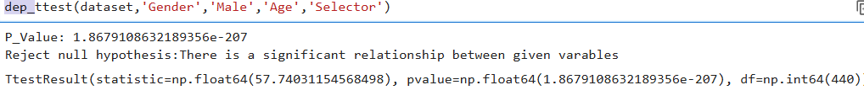
Anova: Analysis of Variance
- Analysis of variance tells the significant difference between two variables
- H0-There is no significant difference between given variables
- H1-There is a significant difference between given variables
One_way Anova:
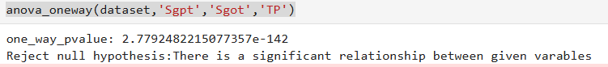
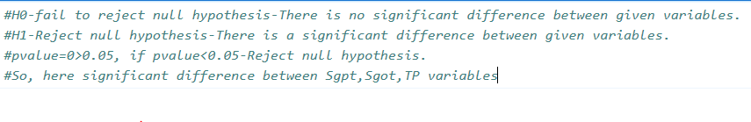
Two_way Anova:
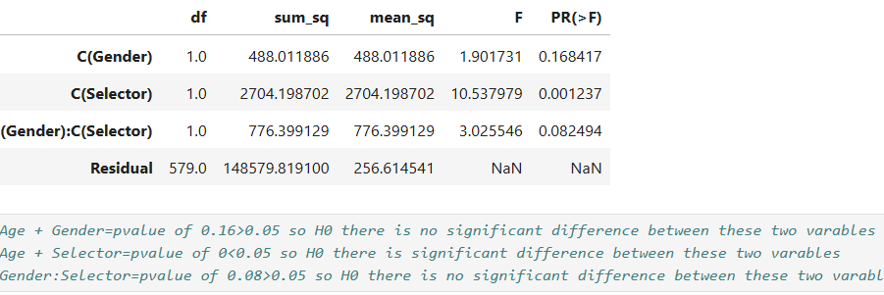

1.How many male and female affect liver disorder?
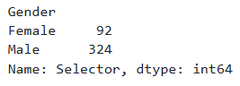
2. Who are all above 60 age affected person?
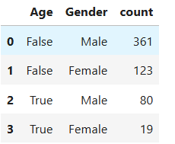
3. Reason for affected person?
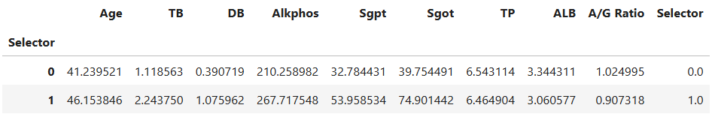
The average of test result of the input features.

